Overview on MI02330 in the context of the apterous gene
- Left side of map is proximal, right side is distal relative to apterous gene
- A ~3kb region of the distal MI02330 was sequenced (grey bar)
- A fragment containing the EGFP reporter is inverted compared to a wildtype MiMIC (pink bar)
- At either end of the inverted fragment, there is a 18 bp duplication (red arrowheads). The duplication between yellow and EGFP is interspersed with 7 bp that are not part of the duplication (small print in sequence file)
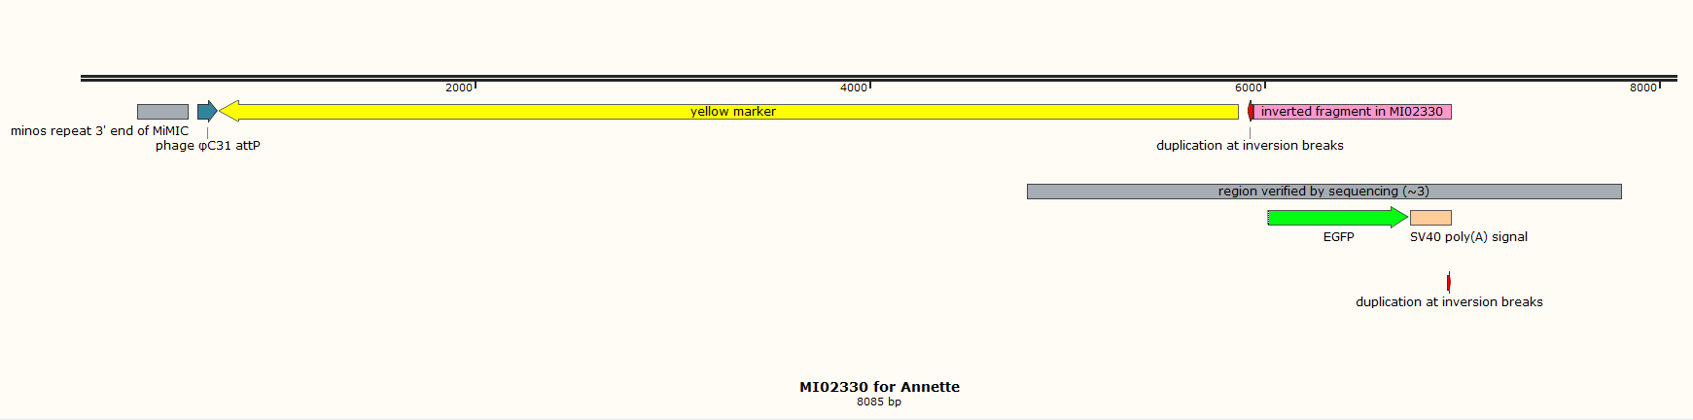
- A 472 bp fragment at the 5’ end of MiMIC is missing (including the minos 5’ repeat and the attP site)

